**Newlove, John (1938 – 2003)**

Molly Hall, University of Rhode Island

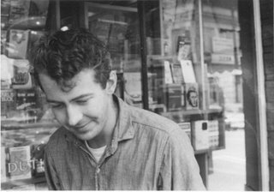**Young John Newlove.**

(url: http://jacketmagazine.com/34/derkson-newlove.shtml)

Born June 13, 1938 in Regina, Saskatchewan, Canada, John Newlove was a poet and editor who helped to define Canadian national literature during a key period of its formation. Never formally finishing college, Newlove spent many years traveling around Canada doing various jobs. He taught high school English in 1957 in Manitoba, and was a social worker in Saskatchewan in 1958, but spent most of his career as a copywriter, editor, and announcer on various radio stations. In 1960 he settled in Vancouver, British Columbia for the remainder of the decade, engrossed in self-guided study and publication in chapbooks and literary and poetry magazines. He spent most of his time reading about poetry, mythology, and the history of exploration in Canada at Vancouver Public Library while being unofficially mentored by fellow artists and poets from the Tish group of poetic masters out of University of British Columbia such as Brian Fisher and Roy Kiyooka, both of whom are also from Saskatchewan.

After his marriage to graphic artist and organizer, Susan Mary Phillips, in 1966 they moved to California, then to Toronto where he began working as a senior editor at McClelland & Stewart, a position he held from 1970 to 1974. Newlove’s *Lies* (1972) won the prestigious Governor General’s Award, initiating a period of more open support for his work. Taking a position as writer-in-residence at the University of Western Ontario in 1975, he traveled from place to place for the remainder of the decade, writing and lecturing at the University of Toronto, Loyola College, Concordia University, Regina Public Library, and David Thompson University.

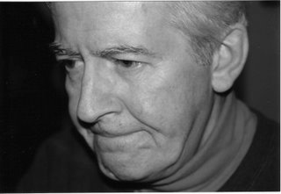**Newlove.**

(url: http://jacketmagazine.com/34/derkson-newlove.shtml)

Winner of Four Canada Council Grants between 1965 and 1981 including the Senior Arts Grant in 1977, Newlove was also awarded the 1984 Saskatchewan Writers' Guild Founders Award and the Literary Press Group Award in 1986. Newlove’s poetry constructs his explorations of individual and national identity around the Canadian landscape, and the immediacy of the subject and body in place and history. He mixes mythology and materialism in his poetics of the land beset by layers of colonial history, situating itself within the prairie poetry tradition and reforming Canadian national literature at the same time. Like many modernist poets, his work reflects the dialectics of proximity and distance, of particularity and universality in his depictions of modernization. The long poem, *The Green Plain* (1981), published originally as a part of *Dreams Surround Us* (1977), on which he collaborated with John Metcalf, plays with affective registers in a modern capitalist age. His work often engages Canadian history and includes descriptions of the landscapes and memories of his early life in Saskatchewan; these childhood prairies became the signature trope of his work. Poems such as the much-anthologized ‘The Pride,’ ‘Ride Off Horizon,’ and ‘Crazy Riel’ imagine a national space which is seized for its people by a bare language which, only in its simplicity, is able to capture the crude reality of such a place, both its violent past and its present vitality.

[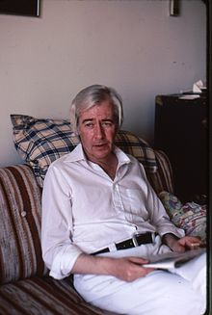](https://en.wikipedia.org/wiki/File:JohnNewlove1980.jpg)**Newlove, 1980.**

(url: https://en.wikipedia.org/wiki/File:JohnNewlove1980.jpg)

His ability to employ an austere poetic syntax which both mirrored the classical purity of form and avoided and resisted the usual tropes and allusions in order to render the beautiful in the terrible, is said to make his poetic vision akin to that which James Joyce had for Stephen Daedalus in *Ulysses*: to embrace the world despite its incoherence. Although his pieces are often described as confessional and homey, they are less personal than honest, as he wanted to circumvent the dissemblance that is language, and failing that, would use silence to signify in its place. After a lack of major publications from 1972 to 1986, he published *The Night the Dog Smiled* (1986) the same year he became the editor for the Commissioner of Official Languages in Ottawa for the Canadian government where he remained until his death. Newlove died suddenly on December 23, 2003 of a brain hemorrhage in Ottawa, though it was preceded by both a stroke and heart attack in his final years.

**Selected List of Works**

Collected Works

*A Long Continual Argument: The Selected Poems of John Newlove* (2001)

Poetry

*Grave Sirs* (1962)

*Elephants, Mothers and Others* (1963)

*Moving in Alone* (1965)

*Notebook Pages* (1966)

*What They Say* (1967)

*Black Night Window* (1970)

*The Cave* (1970)

*Lies* (1972)

*The Fat Man: Selected Poems 1961-1972* (1976)

*The Green Plain* (1981)

*The Night the Dog Smiled* (1986)

*Apology for Absence: Selected Poems 1962-1992* (1993)

‘The Death of the Hired Man’ (2001)

Edited

*Canadian Poetry: The Modern Era* (1977)

*The Collected Poems of F.R. Scott* (1981)

Co-authored

*Dreams Surround Us* (1977, with John Metcalf)

Posthumous Publications

*The Tasmanian Devil & Other Poems* (1999)

**Further Reading**

Atwood, Margaret (1973) ‘How Do I Get Out of Here: The Poetry of John Newlove,’ *Open*

*Letter*, 2(4), 59-70.

Barbour, Douglas (1980) ‘John Newlove: More Than Just Honest Despair; Some Further

Approaches,’ *Essays on Canadian Writing*, 18-19: 258-61.

Barbour, Douglas (1992) *John Newlove and His Works*, Toronto: ECW Press.

Bartly, Jan (1982) ‘An Interview with John Newlove,’ *Essays in Canadian Writing*, 23, 135-

156.

Carpenter, David, Ed. (2014) *The Literary History of Saskatchewan, Volume 2: Progressions*,

Regina, Saskatchewan, Canada: Coteau Books.

Henderson, Brian (1975) ‘Newlove: Poet of Appearance,’ *Essays On Canadian Writing*, 2, 9-27.